DOM Introduction

Using the DOM API we can interact with the HTML elements and the browser window using JavaScript. DOM stands for Document Object Model. It models the HTML document into an object. That means, everything we see in the HTML page is represented as objects in JavaScript.

**DOM**is not a programming language, it is an interface through which JavaScript access the elements of HTML pages.

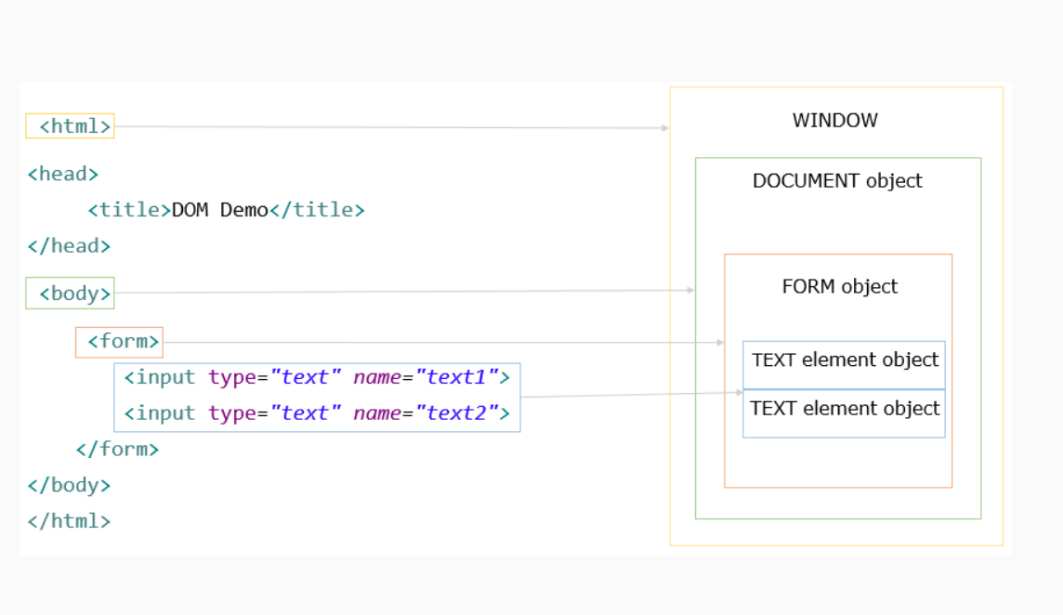

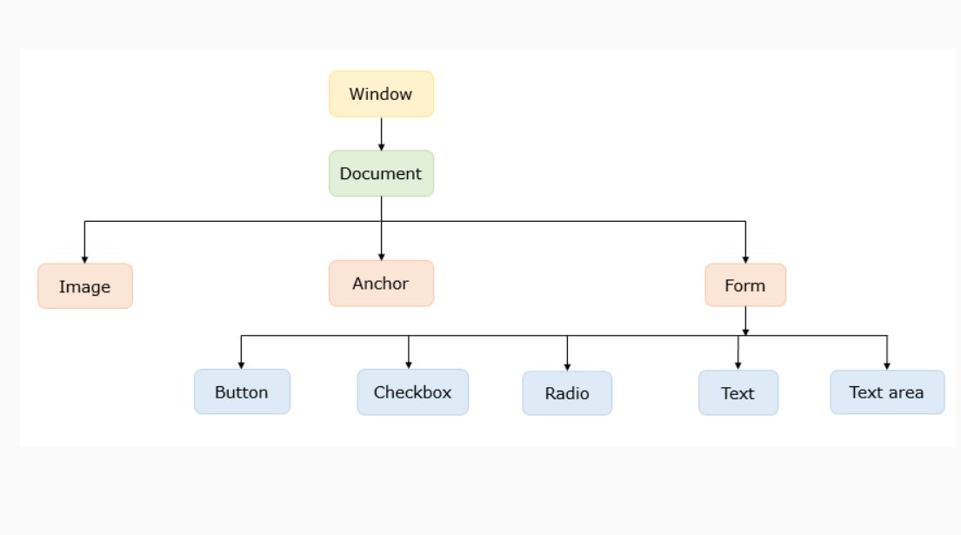

Here are few widely used DOM methods:

**getElementById(id):** It is used to access element by its id.

**getAttr("attributeName"):**It is used to access the tag attribute of the DOM object

Few widely used DOM atttributes:

**innerHTML:** innerHTML is used to set or get the HTML content of the element.

**innerText:** innerText is used to set or get the Text content to element.

**value:** value is used to get or set value of the element.

**checked:** checked is used on checkbox and radio button. It is used to check either they are checked or not. If they are checked, it returns true else it returns false.

**disabled:** disabled is used to get or set the disabled status of the element. If disabled is set to true, then the element becomes disabled.

Some common methods associated with the window object are:

**alert("message")** - this will display an alert box with the given message

**confirm("message")** - this will display an confirm box with the given message

Since window is the top most object, we can ignore it in the code. For example window.alert("Hello") is the same as alert("Hello");

One of the most common method associated with the document object is:

**write("message")**- this will overwrite the existing HTML content of the page with the message given

# DOM Events

The user interacts with the HTML elements and each of these interactions is what we  call as an event. Each of these events have predefined event attributes which link the JS code to these events. Some of the important ones are:

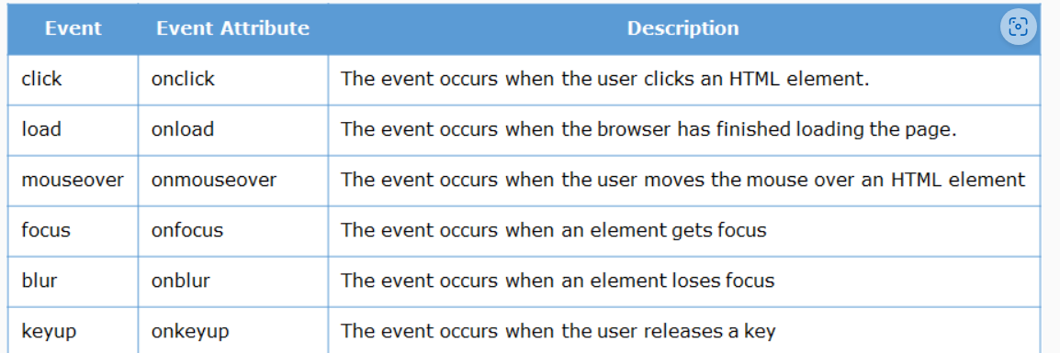

The JavaScript code(called specifically as function) is written to respond to these events are called as **event handlers**.

Now let us understand more with the help of an example.

In this example, we will see how to access text input, checkbox and radio button in DOM as well as how to set HTML to document. The script to access DOM should be after all the DOM elements are loaded. Therefore the script tag for DOM access is placed as the last statement of the body tag

This example will cover previous concepts.

1. <!DOCTYPE html>
2. <html>
3. <head>
4. <title>DOM Example</title>
5. </head>
6. <body>
7. <div>
8. <div>
9. <label for="name">Name: </label>
10. <input type="text" id="name" name="name">
11. </div>
12. <div>
13. <p>Choose you favourite: </p>
14. <input type="checkbox" id="html" name="fav" value="html" />
15. <label for="scales">html</label>
16. <input type="checkbox" id="js" name="fav" value="js" />
17. <label for="scales">js</label>
18. </div>
19. <div>
20. <p>Choose your gender: </p>
21. <input type="radio" id="male" name="gender" value="male" />
22. <label for="huey">Male</label>
23. <input type="radio" id="female" name="gender" value="female" />
24. <label for="huey">Female</label>
25. </div>
26. <button onclick="check()">Submit</button>
27. <div id="nameValue"></div>
28. <div id="checkedValue"></div>
29. <div id="radioValue"></div>
30. </div>
31. <script>
32. function check() {
33. *// name*
34. name = document.getElementById("name").value;
35. document.getElementById("nameValue").innerHTML = "Name: " + name;
36. *// checkbox*
37. html = document.getElementById("html").checked;
38. js = document.getElementById("js").checked;
39. if (html && js) {
40. document.getElementById("checkedValue").innerHTML = "You checked both html and js";
41. }
42. else if (html) {
43. document.getElementById("checkedValue").innerHTML = "You checked html";
44. }
45. else if (js) {
46. document.getElementById("checkedValue").innerHTML = "You checked js";
47. }
48. else {
49. document.getElementById("checkedValue").innerHTML = "You checked none";
50. }
51. *// radio button*
52. male = document.getElementById("male").checked;
53. female = document.getElementById("female").checked;
54. if (male) {
55. document.getElementById("radioValue").innerHTML = "Gender: Male";
56. }
57. else if (female) {
58. document.getElementById("radioValue").innerHTML = "Gender: Female";
59. }
60. }
61. </script>
63. </body>
64. </html>